Nithin S
221IT085

IT150 Lab Assignment 4

1. Write a program to create classes in C++ which apply compile time polymorphism.

CODE

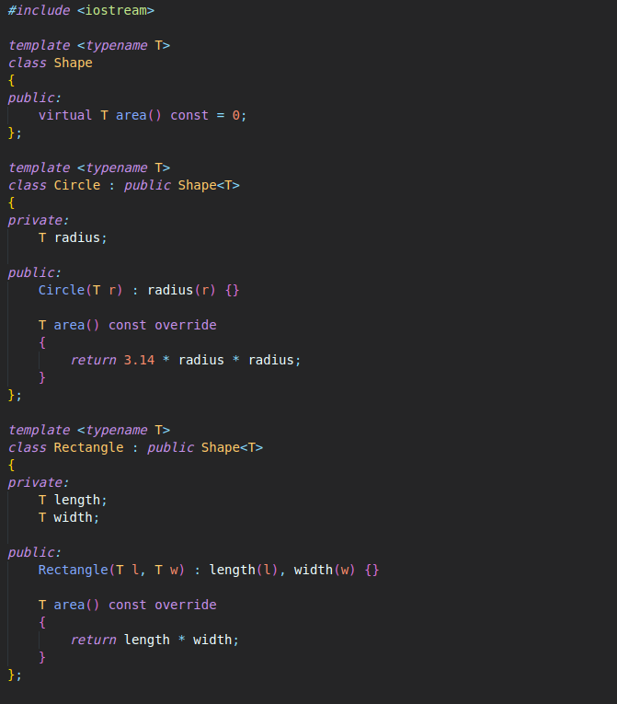
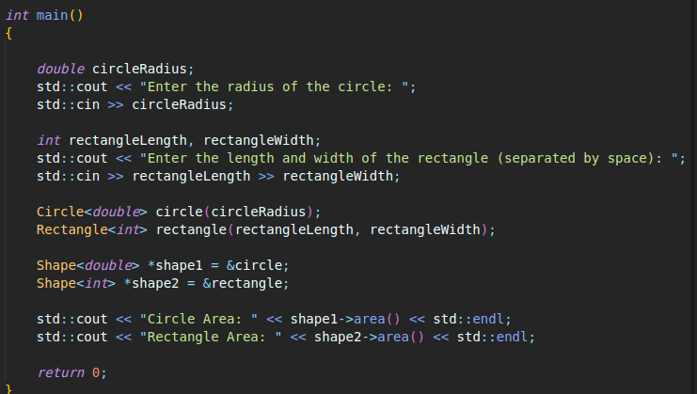

OUTPUT

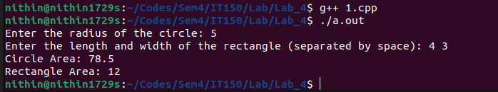

2.Design, implement and test classes in C++ which apply runtime polymorphism

CODE

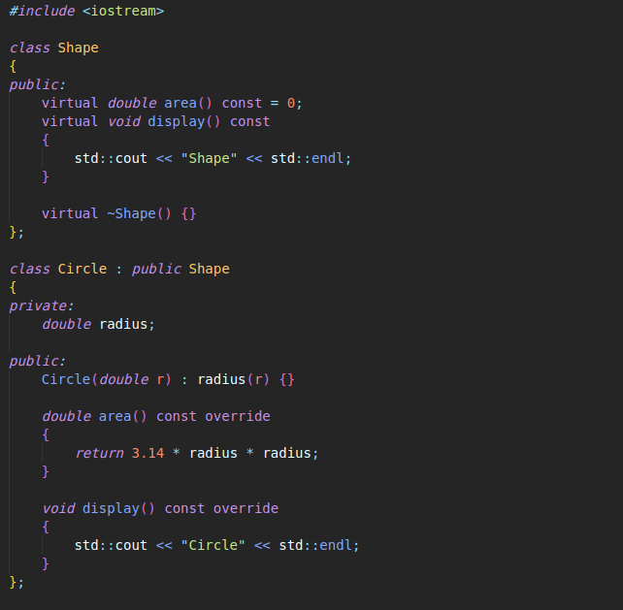

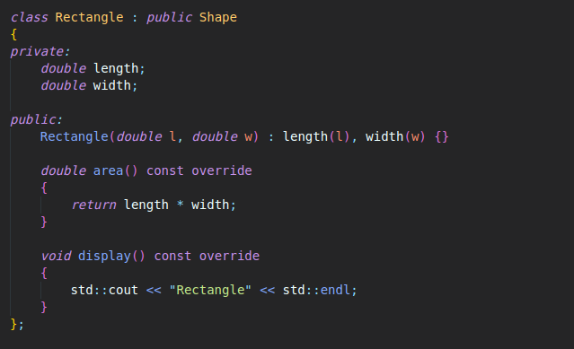
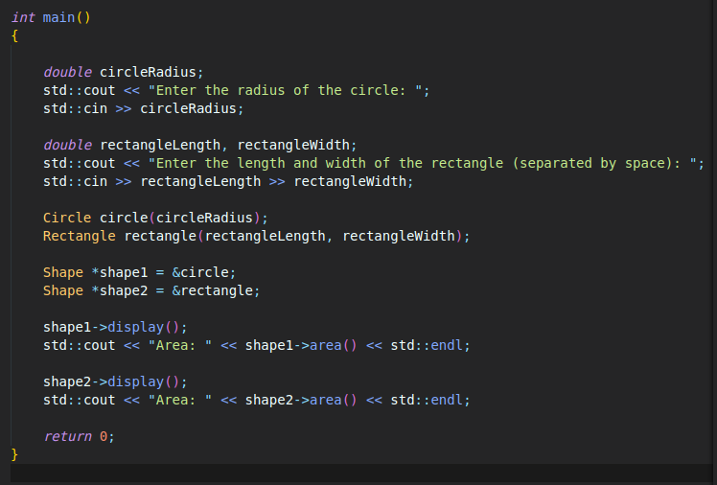
OUTPUT

